1. **Agenda**: Now let me show you two other important pieces of data you can put into your documents.
   1. **Embedded Documents**.
   2. **Arrays**
2. You can use **embedded documents** and this is actually a **core feature of mongodb**. We will discuss it again in “Data Schema” and “Relations Module”
3. 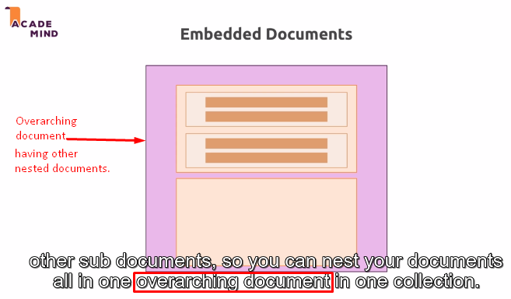  
   **Overarching document**: Document having nested document.
4. So, we can have up to 100 levels of nesting in mongodb. This is **hard limit** but you can have a lot of nesting and to be honest, you rarely need more than three or four levels and you always got another hard limit 🡺 the overall document size has to be below 60 megabytes. That might sound small but since you only store text in there, you don’t store files mongodb for example, you would use your file storage for that.   
   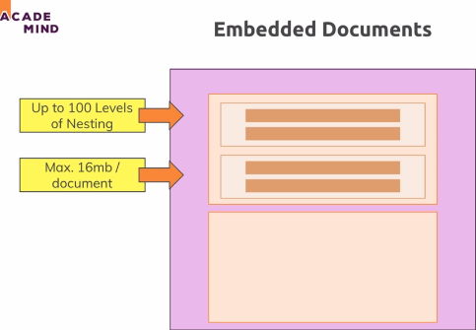
5. Another kind of data that you can store arrays and this is not strictly linked to embedded documents though it can also be documents. You can have arrays in this case of embedded documents but arrays can hold any data. It means you can have a list of data in your document.
6. 